Mutual Exclusion
Train Automation

Name: Nayera Abd El Samie
Id: 4032

Description of the overall organization

To improve the train efficiency by automating consider we have one train in the station every time which is represented by a thread besides a bunch of robot passengers each one is represented by a thread.

We will mutex variable and synchronization functions to do so.
We have 3 major functions, 1 to handle train and the other 2 for the passengers whether they are waiting for the train or the train has arrived.

1- Station_init:

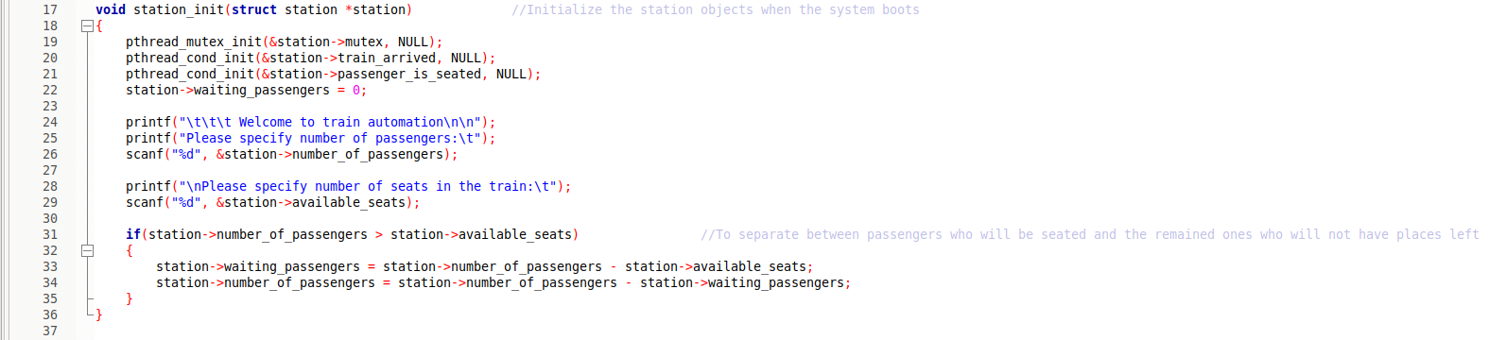
The first method to be invoked is station_init which will initialize all variable we have before booting the system also taking number of passengers and number of seats available in the train.

If we have number of passengers more than the available seats that indicates that we have number of waiting passengers. Number of waiting passengers will be calculated so we when another train arrives they will enter it.

2- Station_load_train:

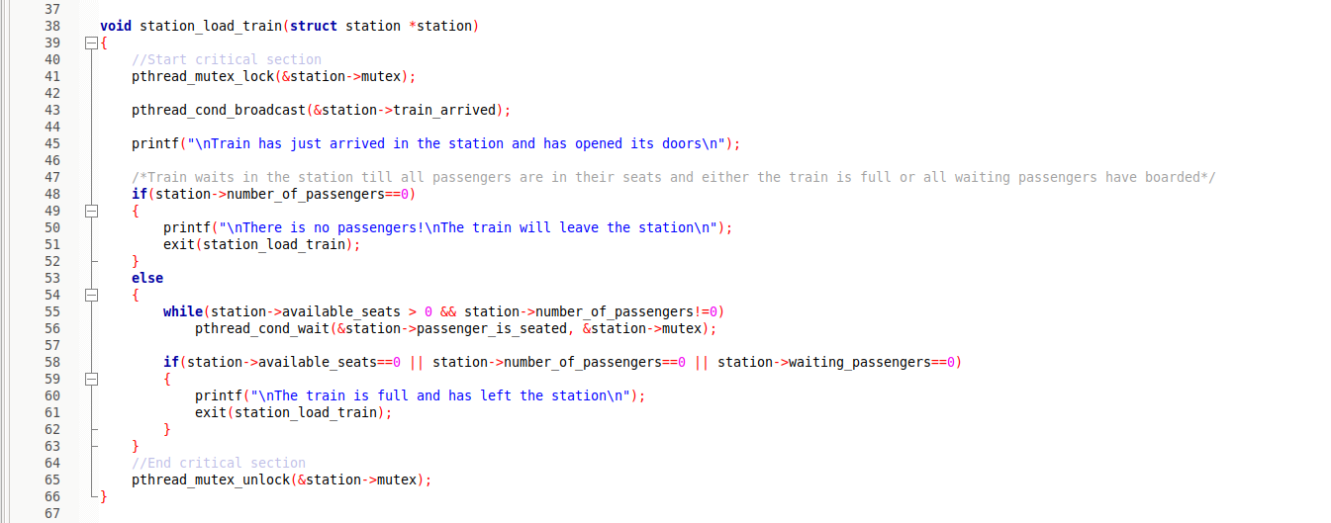
This is the first use of mutex variable which will lock the critical section to avoid entering more than one thread and when the thread finishes its work the critical section is unlocked for another thread to enter.

If there is no passengers the train will automatically leave, else the train will open its doors for the passengers to enter and wait for passengers to seat till one of two scenarios happen whether all seats are taken or there are no passengers waiting then it will leave.

3- Station_wait_for_train:

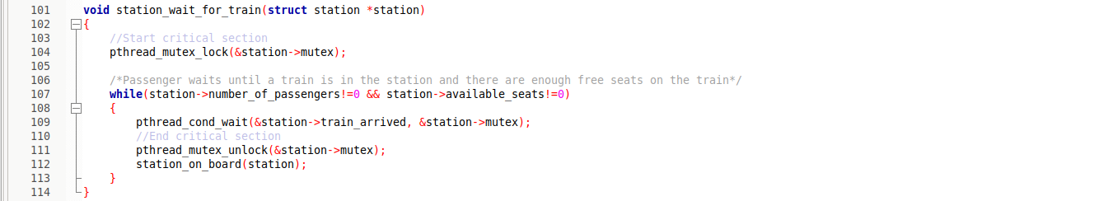
This is the second use of mutex to prevent more than one passenger thread access the critical section at the same time (accessing same seat).

Every passenger thread will wait for the train to arrive condition which is signaled in the previous function, when the train arrives function station_on_board is called to let the passengers seat in the train.

4- Station_on_board:

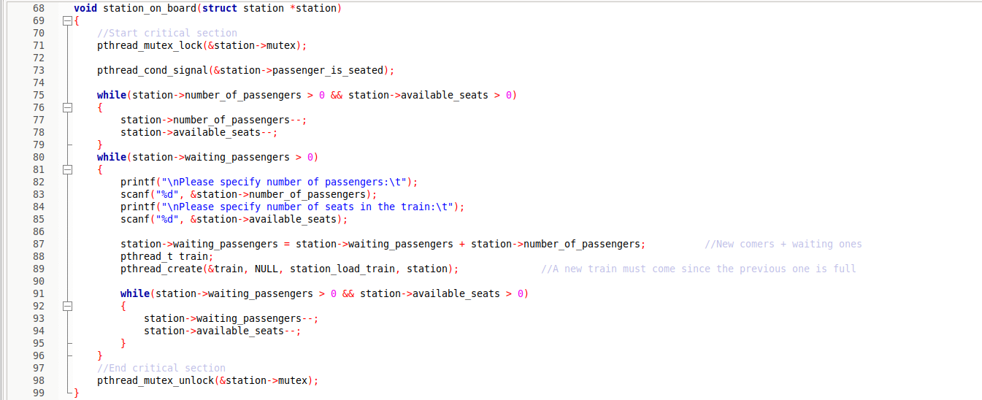
Last function to which is invoked by station_wait_for_train will decrement number of passengers when passenger seat and also will decrement number of seats by one.

We will create a new thread for a new train to arrive for passengers who have been waiting + new comers.

